## Create Office 365 Developer SharePoint Site Collection

This lab requires you first create an Office 365 Developer Site. Visit <http://dev.office.com> and sign up for an Office 365 Developer Site. Once provisioned, create a new site using the Developer Site template at [**https://YourTenant.sharepoint.com/sites/Dev**](https://YourTenant.sharepoint.com/sites/Dev)**.**

# **Exercise 1: Hello Mail App**

In this exercise, you will create a simple Twitter Mail App that will look for Twitter screen names in an email body and will display the recent tweets for that screen name.

## Task 1 – Create a New App

In this task, you will develop a new App in Visual Studio

1. Open Microsoft Visual Studio 2012 and create a new SharePoint App project
   1. Open **Microsoft Visual Studio 2012**
   2. Select **File⮚New Project** from the main menu
   3. Click the **Templates⮚Visual C#⮚Office/SharePoint⮚Apps** node and select the **App for Office 2013** project template
   4. Name the new project **TwitterMailApp.**

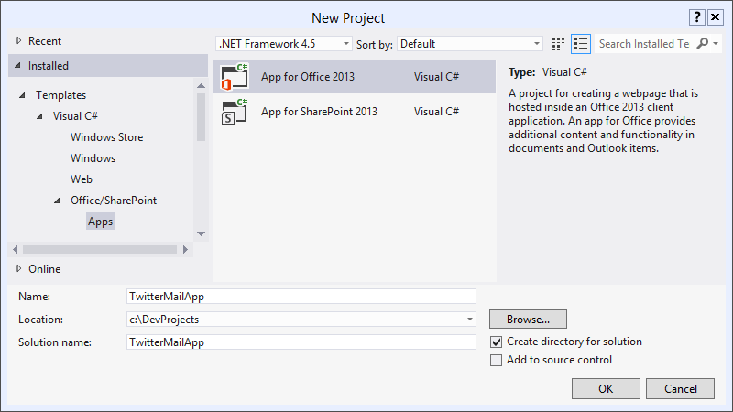

* 1. Click the **OK** button.
  2. In the next screen, choose **Mail app in** and choose **Email Message.**

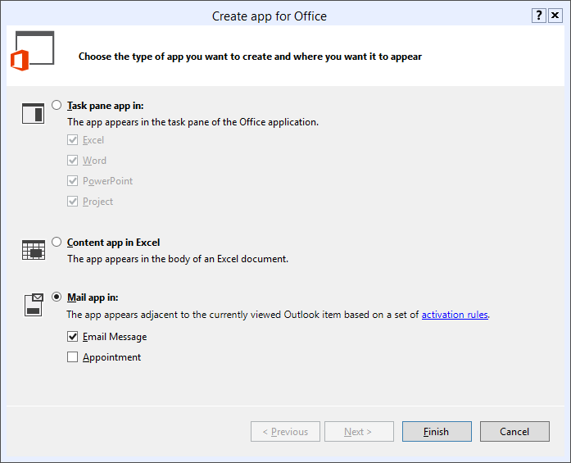

## Task 2 – Implement the App Web

In this task, you will modify the generated ASP.NET web application. You will modify the HTML page structure and provide the javascript implementation for the app.

1. In the **TwitterMailAppWeb** project, open the **TwitterMailApp.html** page. Leave the content in the **head** section as-is. Modify the content in the **body** section:

<div>

<p id="message">

<!-- The following content will be replaced with the user name when you run the app -->

initializing...

</p>

</div>

1. Modify the **TwitterMailApp.js** file with the following:

// This function is run when the app is ready to start interacting with the host application

// It ensures the DOM is ready before updating the span elements with values from the current message

Office.initialize = function () {

$(document).ready(function () {

init(Office.context.mailbox.item.getRegExMatches().ScreenName);

});

};

function init(screenNames) {

for (var i = 0; i < screenNames.length; i++) {

getTwitterData(screenNames[i]);

}

}

function getTwitterData(screenName) {

$.ajax({

url: "https://api.twitter.com/1/statuses/user_timeline.json",

type: "GET",

dataType: "jsonp",

data: {

screen_name: screenName,

include_rts: true,

count: 5,

include_entities: true

},

success: onDataReturned,

error: onError

});

}

function onDataReturned(data) {

var ret = [];

ret.push("<h1>Tweets for " + data[0].user.screen_name + "</h1>");

ret.push("<table><th>Text</th><th>Time</th><tr>");

for (var i = 0; i < data.length; i++) {

ret.push("<tr>");

ret.push("<td>" + data[i].text + "</td>");

ret.push("<td>" + data[i].created_at + "</td>");

ret.push("</tr>");

}

ret.push("</table>");

$('#message').html(ret.join(''));

}

function onError(data, something, another) {

alert(data);

}

## Task 3 – Modify the app manifest

In this task, you will modify the app manifest to provide the location of the app and the activation rules for the app.

1. Open the **AppManifest** designer by double-clicking on the **TwitterMailApp** node in solution explorer.
2. Open the **Activation Rules** tab to set activation rules for the app.
   1. Click the **Any of the following rules** node and change the radio button to select **All of the following rules.**
   2. Click the **Add** node to add a new activation rule. In the drop-down, choose **item has a regular expression**.

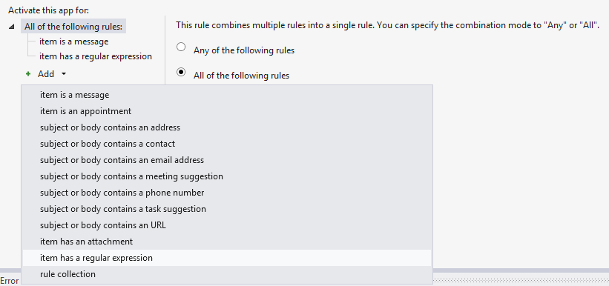

1. Click the **item has a regular expression** node, and change the property name to **BodyAsPlaintext**.
2. Change the RegEx name to **ScreenNames**. Use the simple regular expression:

**SPConf|SharePoint|andrewconnell|kaevans**

1. Check the checkbox to ignore case.

## Task 4 – Test the App

In this task, you will run and test the App. We deploy the app manifest to Exchange, but the implementation of the app runs in our local IIS Express development server.

* 1. Select **Debug⮚Start Debugging** in Visual Studio.
  2. When prompted for credentials, enter your Office 365 User ID as the email address and provide your password.

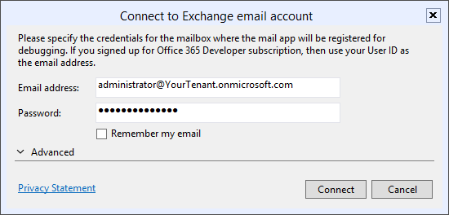

* 1. Observe the **Output Window** for installation messages, and verify that **Internet Explorer** opens to the SharePoint Apps site you created before starting the lab.
  2. Send yourself an email message that contains the body text:

**Can’t wait for SharePoint Conference!**

* 1. Verify that the HTML table is rendered with recent tweets from the @SharePoint twitter user.

# **Exercise 2: YouTube Mail App**

In this exercise, you will create a Mail App that will allows users to view a YouTube video from a message or appointment item that contains the video URL, without leaving Outlook 2013.

## Task 1 – Create a New App

In this task, you will develop a new App in Visual Studio

1. Open Microsoft Visual Studio 2012 and create a new SharePoint App project
   1. Open **Microsoft Visual Studio 2012**
   2. Select **File⮚New Project** from the main menu
   3. Click the **Templates⮚Visual C#⮚Office/SharePoint⮚Apps** node and select the **App for Office 2013** project template
   4. Name the new project **YouTubeMailApp**
   5. Click the **OK** button

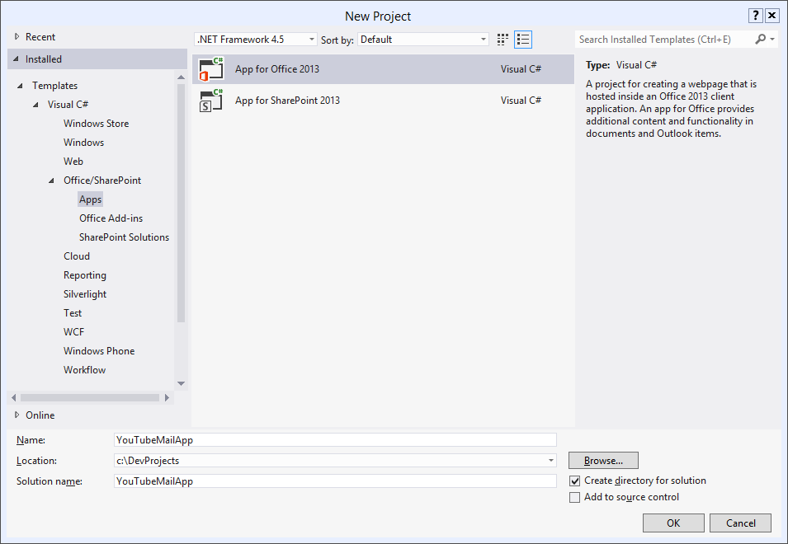

*Create new SharePoint App Project*

1. In the next screen, choose **Mail app in** as the type of app, and check the **Email Message** checkbox.



1. Click **Finish**.

## Task 2 – Implement the App Web

In this task, you will modify the generated ASP.NET web application. You will add a logo for the app, provide the CSS styles for the app, modify the HTML page structure, and provide the javascript implementation for the app.

1. Two projects are created, **YouTubeMailApp** and **YouTubeMailAppWeb**. Add an the YouTubeLogo.png image from the **Required Files** folder of the lab documents to the **Content** folder in YouTubeMailAppWeb.

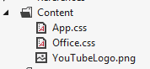

1. **Edit** the file **App.css**. **Replace** the contents with the following:

*

{

margin: 0px;

overflow: hidden;

}

.thumbnailFrame

{

margin-bottom: 4px;

}

.thumbnail

{

margin-right: 4px;

}

.videoTitle

{

font-family: Segoe UI;

font-size: 16px;

}

.multiLineVideoDetails

{

font-family: Segoe UI;

font-size: 14px;

color: Gray;

}

.singleLineVideoDetails

{

font-family: Segoe UI;

font-size: 12px;

color: Gray;

}

1. **Edit** the file **YouTubeMailApp.html**. Leave the **head** section as-is. **Replace** the **body** section with the following:

<table cellpadding="0px" cellspacing="0px" style="table-layout: fixed" height="200px">

<tr>

<td id="thumbnails" valign="top" />

<td id="embeddedVideo" valign="top" />

<td valign="top">

<div id="details" style="margin-left: 10px; height: 200px; overflow: auto" />

</td>

</tr>

</table>

1. Now it’s time to provide the implementation. **Replace** the contents of the **YouTubeMailApp.js** file with the following contents.

var videos;

var selectedVideo = -1;

Office.initialize = function (reason) {

$(document).ready(function () {

init(Office.context.mailbox.item.getRegExMatches().VideoURL);

});

}

function parseDate(dateString) {

var year = parseInt(dateString.substring(0, 4));

var month = parseInt(dateString.substring(5, 7));

var day = parseInt(dateString.substring(8, 10));

var result = new Date();

result.setUTCFullYear(year);

result.setUTCMonth(month - 1);

result.setUTCDate(day);

return result;

}

function getVideoIndex(videoId) {

for (i = 0; i < videos.length; i++) {

if (videos[i].Id == videoId) {

return i;

}

}

return null;

}

function videoDetailsLoaded(videoFeed) {

var videoIndex = getVideoIndex(videoFeed.entry.id.$t.substring(42));

if (videoFeed.entry.media$group.media$thumbnail.length > 0) {

videos[videoIndex].ThumbnailURL = videoFeed.entry.media$group.media$thumbnail[0].url.replace("http:", "https:");

document.getElementById(videos[videoIndex].Id).src = videos[videoIndex].ThumbnailURL;

}

videos[videoIndex].Title = videoFeed.entry.title.$t;

videos[videoIndex].PublishedDate = parseDate(videoFeed.entry.published.$t);

videos[videoIndex].Description = videoFeed.entry.media$group.media$description.$t;

videos[videoIndex].ViewCount = parseInt(videoFeed.entry.yt$statistics.viewCount);

if (videoIndex == selectedVideo) {

refreshVideoDetails(selectedVideo);

}

}

function loadVideoDetails(videoIndex) {

var script = document.createElement("script");

script.setAttribute("src", "https://gdata.youtube.com/feeds/api/videos/" + videos[videoIndex].Id + "?alt=json-in-script&callback=videoDetailsLoaded");

document.getElementsByTagName('head')[0].appendChild(script);

}

function refreshVideoDetails(videoIndex) {

var html = "";

if (videos[videoIndex].Title != undefined) {

html += "<p class='videoTitle'>" + videos[videoIndex].Title + "</p>";

}

if (videos[videoIndex].Description != undefined) {

html += "<p class='multiLineVideoDetails'>" + videos[videoIndex].Description + "</p>";

}

if (videos[videoIndex].PublishedDate != undefined) {

html += "<p class='singleLineVideoDetails' style='margin-top: 8px;'>" + videos[videoIndex].PublishedDate + "</p>";

}

if (videos[videoIndex].ViewCount != undefined) {

html += "<p class='singleLineVideoDetails'>" + videos[videoIndex].ViewCount + "</p>";

}

document.getElementById("details").innerHTML = html;

}

function selectVideo(videoIndex) {

selectedVideo = videoIndex;

for (i = 0; i < videos.length; i++) {

document.getElementById(videos[i].Id + "frame").style.background = i == videoIndex ? "Black" : "White";

}

// document.getElementById("embeddedVideo").innerHTML = "<iframe width='354' height='200' frameborder='0' src='https://www.youtube.com/embed/" + videos[videoIndex].Id + "?autohide=1&showinfo=0'/>";

document.getElementById("embeddedVideo").innerHTML = "<iframe width='354' height='200' frameborder='0' src='https://www.youtube.com/embed/" + videos[videoIndex].Id + "?html5=True'/>";

refreshVideoDetails(videoIndex);

}

function init(videoURLs) {

var html = "";

videos = new Array();

for (i = 0; i < Math.min(videoURLs.length, 5) ; i++) {

var questionMarkPosition = videoURLs[i].indexOf("?v=");

var videoId;

if (questionMarkPosition >= 0) {

videoId = videoURLs[i].substr(questionMarkPosition + 3, 11);

}

else {

videoId = videoURLs[i].substr(16, 11);

}

videos[i] = { "Id": videoId };

html += "<div class='thumbnailFrame' id='" + videos[i].Id + "frame'><img class='thumbnail' id='" + videos[i].Id + "' width='32' height='32' onclick='selectVideo(" + i + ");'/></div>";

loadVideoDetails(i);

}

document.getElementById("thumbnails").innerHTML = html;

if (videos.length == 1) {

document.getElementById("thumbnails").style.display = "none";

}

selectVideo(0);

}

## Task 3 – Modify the App Manifest

In this task, you will modify the app manifest to point to the newly created app and will update the activation rules for the app.

1. Open the **AppManifest** designer by double-clicking on the **YouTubeMailApp** node in the YouTubeMailApp project.

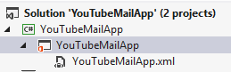

1. Provide an app icon and change the height.
   1. On the **General Settings** tab, change the **Icon** property to point to the **YouTubeLogo.png** file that was added to the app web.
   2. Use the value **YouTubeMailAppWeb/Content/YouTubeLogo.png** for the **Icon** property.
   3. Change the **Requested Height** to **216**.

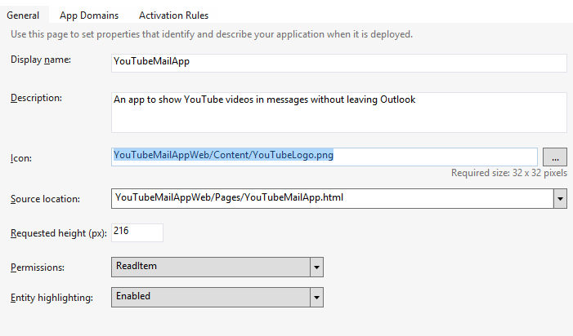

1. Open the **Activation Rules** tab to set activation rules for the app.
   1. Click the **Any of the following rules** node and change the radio button to select **All of the following rules.**
   2. Click the **Add** node to add a new activation rule. In the drop-down, choose **item has a regular expression**.



* 1. Click the **item has a regular expression** node, and change the property name to **BodyAsPlaintext**.
  2. Change the RegEx name to **VideoUrl**.
  3. Change the **Regex value** to the following:

**http://(((www\.)?youtube\.com/watch\?v=)|(youtu\.be/))[a-zA-Z0-9_-]{11}**

* 1. Check the **Ignore case** checkbox.

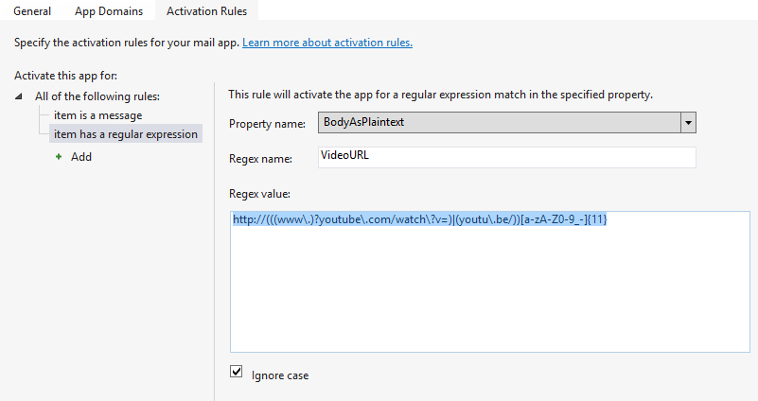

* 1. In the **File** menu in Visual Studio, choose **Save All** to save your work.

## Task 4 – Test the App

In this task, you will run and test the App. We deploy the app manifest to Exchange, but the implementation of the app runs in our local IIS Express development server.

* 1. Select **Debug⮚Start Debugging** in Visual Studio.
  2. When prompted for credentials, enter your Office 365 User ID as the email address and provide your password.



* 1. Observe the **Output Window** for installation messages, and verify that **Internet Explorer** opens to the SharePoint Apps site you created before starting the lab.
  2. Send yourself an email message to your Office 365 inbox **without** a link to a YouTube video. Observe that the app does not appear in the email window.
  3. Send yourself an email message to your Office 365 inbox **with** a link to a YouTube video in the email body.

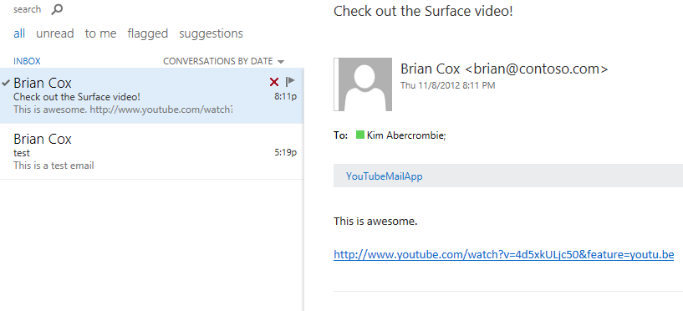

* 1. Click the link to the **YouTubeMailApp**. Notice the warning window that appears. This is because we are using our localhost development server that does not have a trusted certificate. Click the **Show content** button to continue.
  2. The app is rendered and we can see the thumbnail preview of the video along with details of the video, all within Outlook.

